# DC Booster Cable

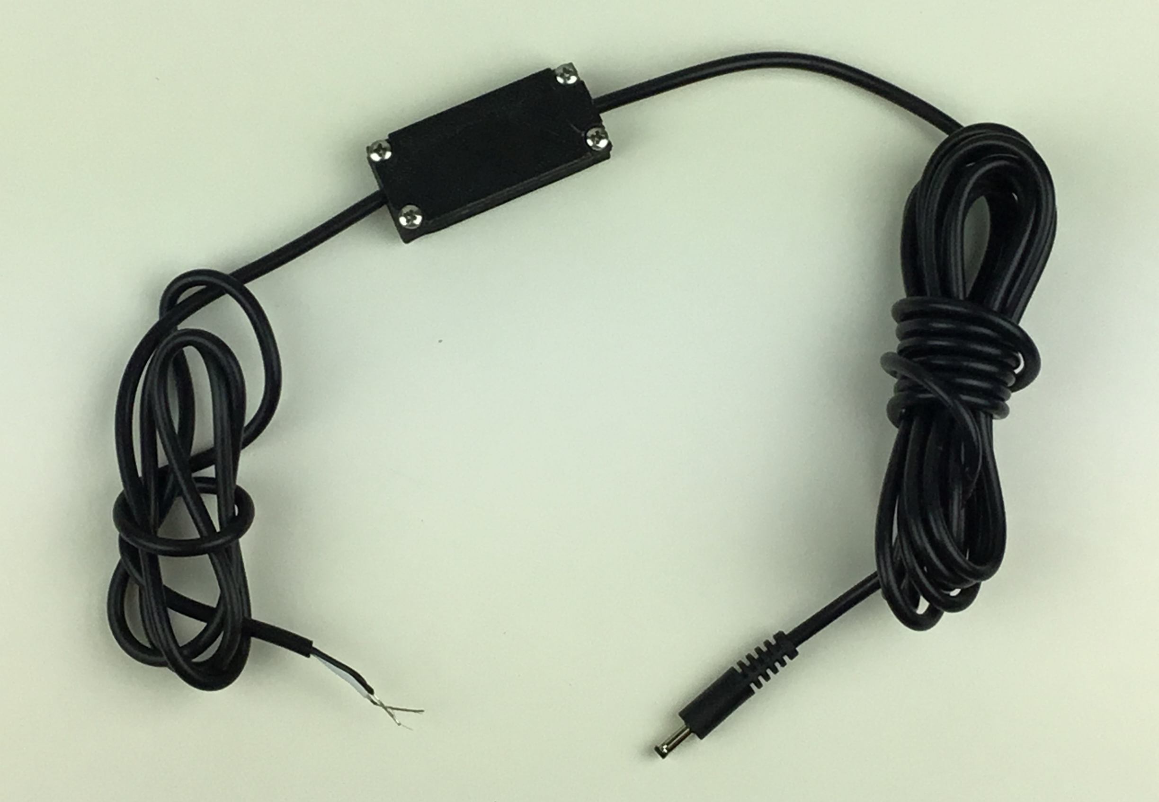

**** Supplies Needed For This Project ****

(1) Old Firefly cable with desired length

<https://shootfirefly.com/pages/product-details>

(1) COVVY DC to DC Step Up Boost Converter MT3608

<https://www.amazon.com/dp/B07SF5N184?psc=1&ref=ppx_yo2_dt_b_product_details>

(4) uxcell M3x5mm Machine Screws Pan Phillips Cross Head Screw 304 Stainless Steel Fasteners Bolts 100Pcs - These are the typical screw used for mounting PC motherboards or PCBs

<https://www.amazon.com/gp/product/B07MF31JJ6/ref=ppx_yo_dt_b_search_asin_title?ie=UTF8&psc=1>

Download and print one set of DC Booster clips (1) DC Booster Clip Top.stl and (1) DC Booster Clip Bottom.stl

**** Procedure for Making Cable ****

1. Splice into cable a few feet from the end. Only expose 1/2 – 7/8" of the black and white wire inside.
2. Strip away 3/16 – 1/4" of wire from both the black and white wire.
3. Solder the white wire from the cable end that connects to the FireFly to the +In solder pad. You can stick part of the wire through the hole on the pad to make it easier to solder and to ensure good connection.
4. Solder the black wire from the cable end that connects to the FireFly to the -In solder pad. You can stick part of the wire through the hole on the pad to make it easier to solder and to ensure good connection.
5. Solder the white wire from the cable end that connects your sequencer to the +Out solder pad using the same procedure from before.
6. Solder the white wire from the cable end that connects your sequencer to the +Out solder pad using the same procedure from before.
7. Apply power to the cable by pressing a test fire or from a socket connected to a power supply unit.
8. Connect a bolt meter to the exposed wires on the end of the cable to touching the +Out and –Out solder pads.
9. Adjust the brass screw on the DC to DC step up / booster MT3608 to desire voltage.
10. Place assembly into the 3D print booster clip
11. Ensure the black cable casing is placed inside the booster clip so the clip will clamp around the cable when closed (see image below).

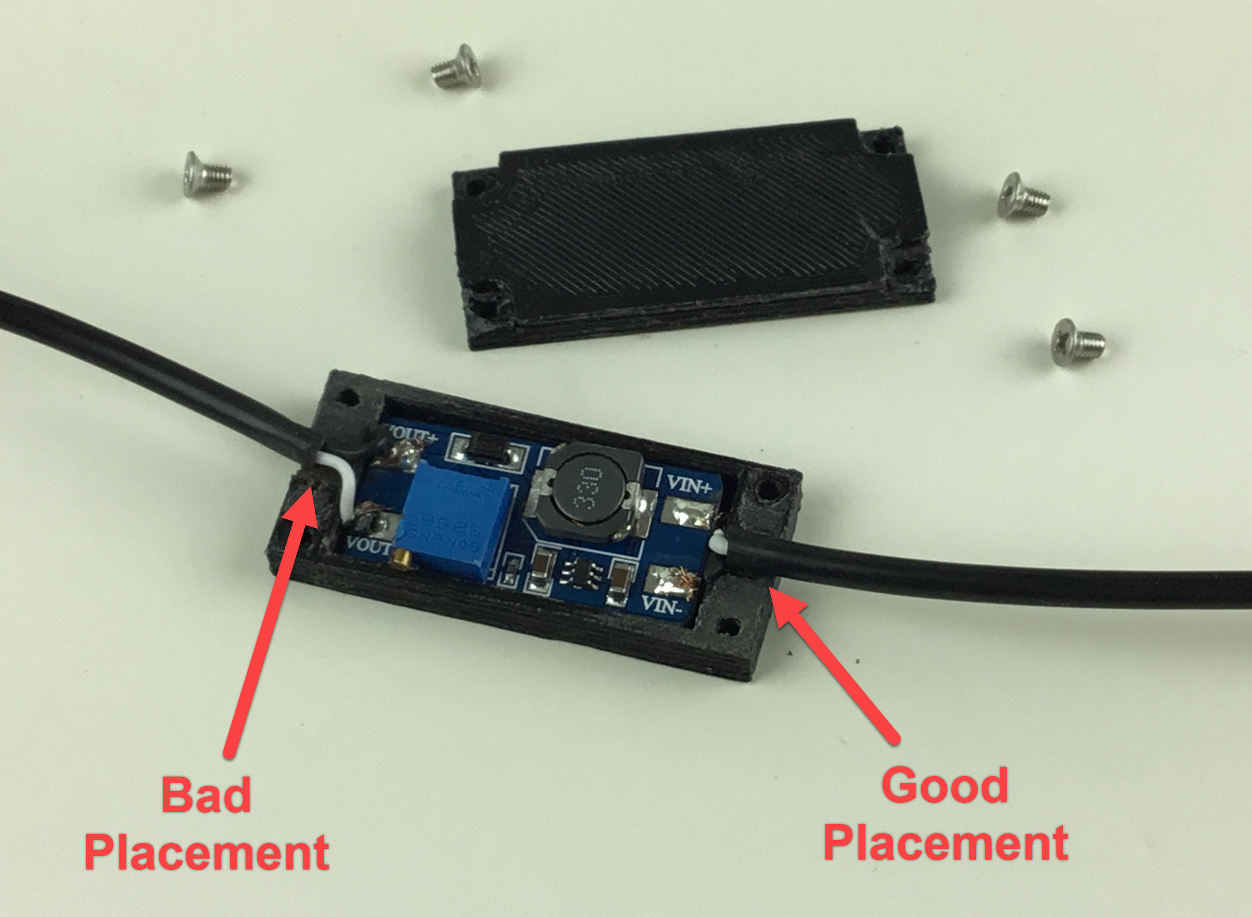

1. Secure lid using (4) M3x5mm pan head machine screws. (These are the typical screws used for mounting PC mother boards or PCB boards.)